Solution Design Document

10in6(PC)-QAD Integration and Automation

**Process Name**: 10in6(PC)-QAD Integration and Automation

**Prepared by**: Netlink

**Date Prepared**: 22-07-2019

**Last Updated**: 22-07-2020

**Version**: 1.0.10

TABLE OF CONTENTS

1 DOCUMENT HISTORY 3

2 DEVELOPERS 3

3 GLOSSARY OF TERMS 3

4 DETAILED PROCESS FLOW 3

5 FLOW CHART 4

6 EXCEPTIONS 5

7 PROCESS CONFIGURATION 5

8 Field Mapping 5

# DOCUMENT HISTORY

|  |  |  |  |
| --- | --- | --- | --- |
| **Version** | **Description** | **Date** | **Author** |
| 1.0 | Initial Draft | 22-07-2019 | Shishir |

# DEVELOPERS

|  |  |
| --- | --- |
| **Name** | **Package Version** |
| Shishir |  |

# GLOSSARY OF TERMS

The following table includes definitions for any abbreviations or notations that are used in the document:

|  |  |
| --- | --- |
| **Term** | **Definition** |
| RPA | Robotic Process Automation |
| PC | Production Count |

# DETAILED PROCESS FLOW

Step 1 – Robot will connect to 10in6 database with valid credentials

Step 2 – Lock the record in the database before reading

Step 3 – Run a “select” query to read the production count of each element from the record.

Step 3 – After completion of query execution, robot will update the production count of the element in QAD screens.

Step 4 – As the QAD is updated with the data, the Robot will update the status column in a particular table for the element so that no changes are made in 10in6 database to that element in the record

Step 5 – This process continue for all the elements.

Step 6 – After completion of the process, Robot will disconnect from the 10in6 database and from QAD system.

# FLOW CHART

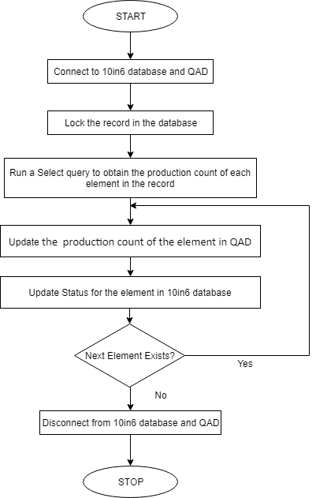

# EXCEPTIONS

|  |  |
| --- | --- |
| **SNo** | **Exception** |
| 1 | Employee number does not exist |
| 2 | The month of a date must be from 1 to 12 |
| 3 | Day in month is invalid |
| 4 | Invalid period/year |
| 5 | Site does not exist |
| 6 | Item number does not exist |
| 7 | Operation does not exist |
| 8 | Site production Line does not exist |
| 9 | Quantity available in site location for lot/serial 22 (in case if you gave negative qty) |

# PROCESS CONFIGURATION

1 - “Config.xlsx” Contains all the Config data like Url, Retry No etc. used in the Process.

# Field Mapping

**Production Qty**

|  |  |  |  |  |
| --- | --- | --- | --- | --- |
| **Field Name** | **Description** | **Data Type** | **QAD Menu** | **QAD Field** |
| SiteReference | 982 for St. Catharines and 984 for TIllsonburg | int | 18.22.13 | Site |
| WorkCenter | Translation of 101n6 Asset Name to CAD's Cell Name | varchar(25) | 18.22.13 |  |
| Routing Code | Translation of 10i n6 Part Names to OAD routing code | varchar(2S) | 18.22.13 | Item Number |
| Operation | Mapping to Operation # as per QAD routing table | varchar(10) | 18.22.13 | Operation |
| ReportingDay | Day of Production Counts to be entered | Date | 18.22.13 | Effective |
| ReportingShift | Shift Name of Production Counts to be entered | varchar(25) | 18.22.13 | Shift |
| ReportingHour | Optional: If reporting is to be done on an hourly basis vs. Shift | varchar(25) | Optional |  |
| Employee ID | ID of employee who was logged into the cell | int | 18.22.13 | Employee |
| Employee Name | Name of employee who was logged into the cell | varchar(50) | 18.22.13 |  |
| GoodPartCount_10in6 | Actual Count from 10i rii5 of Pieces produced during this reporting period (do not update QAD based on this number) | int | NA |  |
| OADGood Pa rtCount | Count of good pieces produced during this reporting period to be used to update OAD | int | 18.22.13 |  |
| AuthorizationID | ID of employee who authorized the CLAD count override (if not equal to the 11 n6 count) | int | 18.22.13 |  |
| AuthorizationName | Name of employee who authorized the QAD count override | varchar(5/) | 18.22.13 |  |
| UploadFlag | Set to 'N' when record is inserted by lain& Set to 'Y' after data has been submitted to QAD | .char(1) | 18.22.13 |  |
| Status | Either "TESTMODE" or "PRODUCTION' if the cell is in a testing mode. | Varchar( SO) | 18.22.13 |  |

**Scrap Qty**

|  |  |  |  |  |
| --- | --- | --- | --- | --- |
| **Field Name** | **Description** | **Data Type** | **QAD Menu** | **QAD Field** |
| Routing Code | Translation of 10i n6 Part Names to OAD routing code |  | 36.10.13.8 | Item Number |
| Operation | Mapping to Operation # as per QAD routing table |  | 36.10.13.8 | Operation |
| Scrap Count | Qty |  | 36.10.13.8 | Qty |
| Reason Code | ReasonCode |  | 36.10.13.8 | ReasonCode |
| SiteReference | 982 for St. Catharines and 984 for TIllsonburg |  | 36.10.13.8 | Site |
| Employee ID | ID of employee who was logged into the cell |  | 36.10.13.8 | Employee |
| ReportingDay | Day of Production Counts to be entered |  | 36.10.13.8 | Effective Date |
|  | Location | No action | 36.10.13.8 | Location |
|  | Charge to | No action | 36.10.13.8 | Charge to |
|  | Remarks | No action | 36.10.13.8 | Remarks |
|  | Project Code | No action | 36.10.13.8 | Project Code |